User Manual of RFID IOT APK

This APK based on Android OS. Android version 4.0.3 and above version supports.

Open RFID IOT APP, you can choose the language you need. Switch language on the upper-right corner

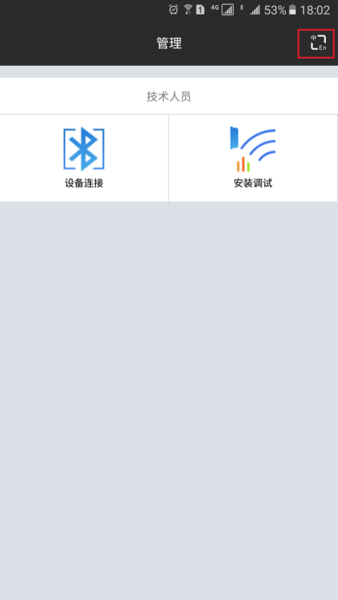

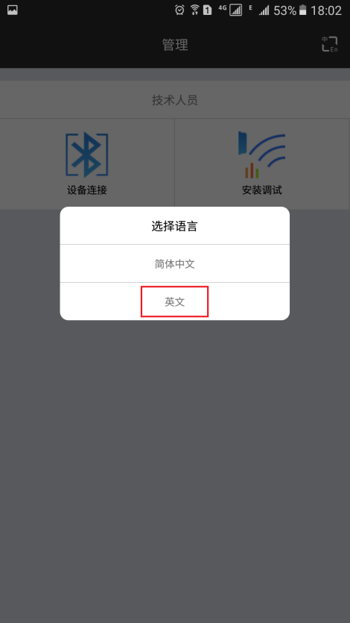

The second option is English

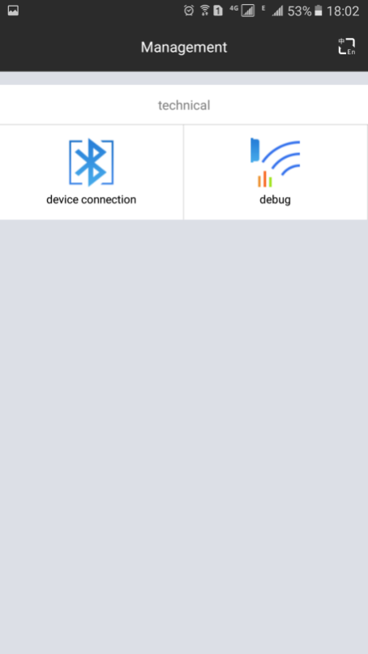

Before connect RFID devices, make sure Mobile phone Bluetooth opened.

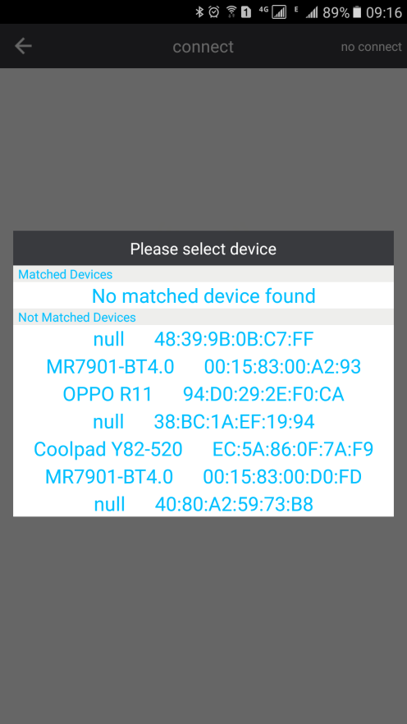

Choose the correct device name. Device will be connected automatically without any password. After connect success, you will see these info:

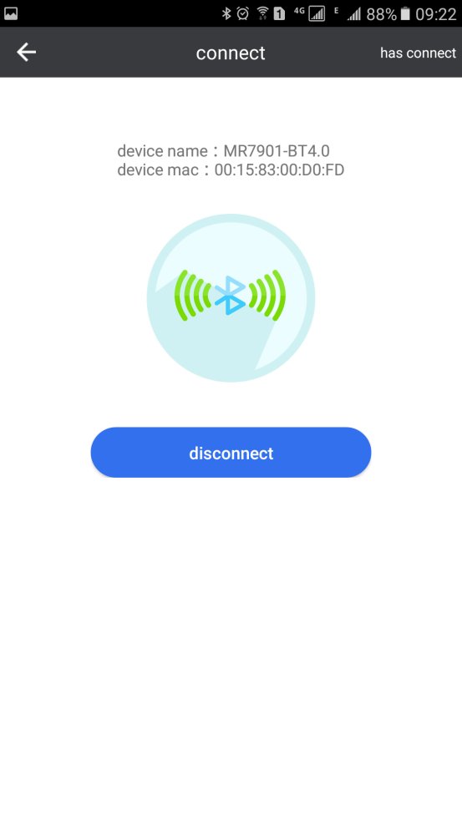

(Note: If request mach password, you can use 1234)

After this, you can config RFID reader parameters, Antenna parameters, Platform info ect.

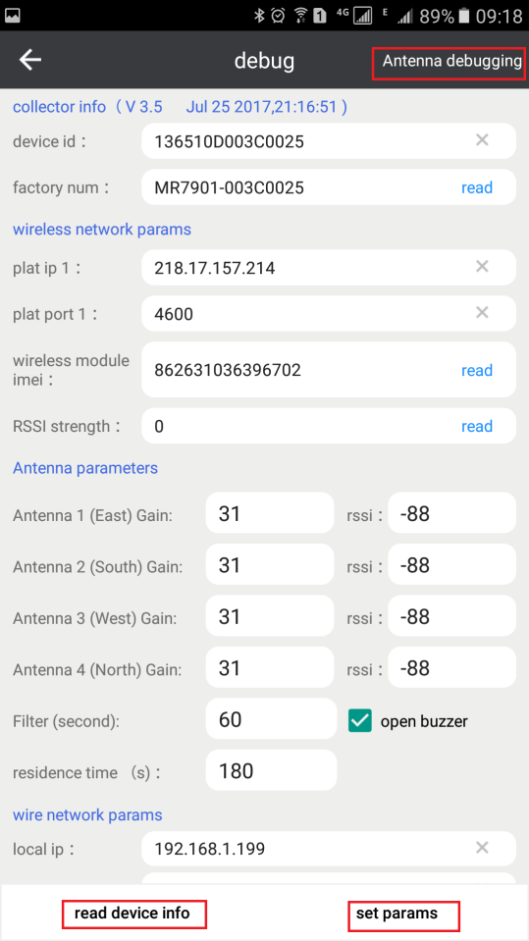

Collector info

A, V3.5 this is software version of base station MR7901

B, Jul 25 2017,21:16:52 this is the time of software version

Device ID:

This 15bytes ID can be write by customer.

Factory num: is the name of device, should to get separately.

Wireless network params

This is the target server parameters.

Antenna parameters

When click read device info button, this antenna parameter will display default parameters value. These parameters can be set manually. After set new value, you can use Antenna debugging option( on the upper-right corner) to check each antennas working status.

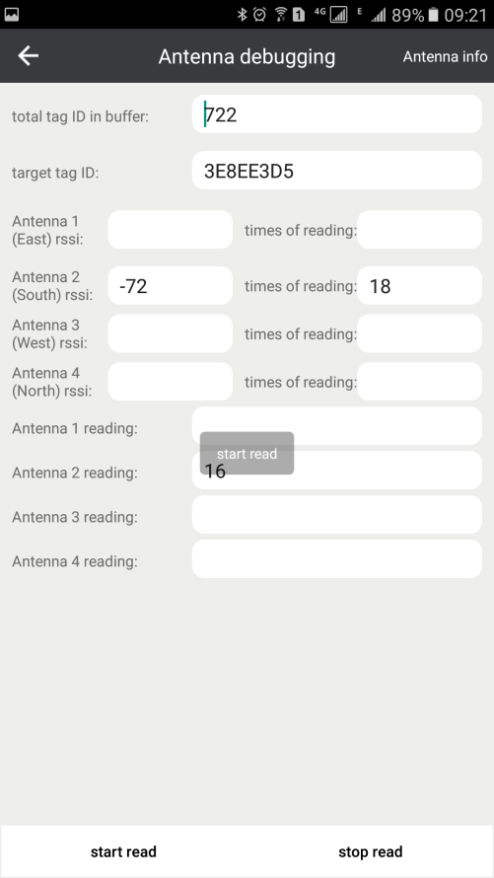

Click antenna info (upper-right corner) can check antennas information.

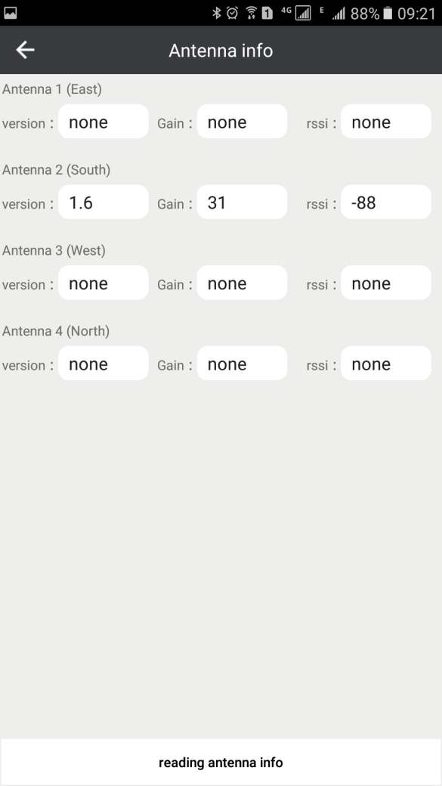

Gain range 0~31

Set 31dbi, antenna will reach MAX reading range 400m, Set 0dBi, will be MIN reading range few meters. Different environment may vary.

RSSI range -128~0

RSSI range used to filter tag data, if tag RSSI value less than current value, tag data will be filter.

Filter value range 0~65526

Within current value, same tag ID just transfer once.

Residence time value range 0，60~65535

Within current value, same tag ID just transfer once.

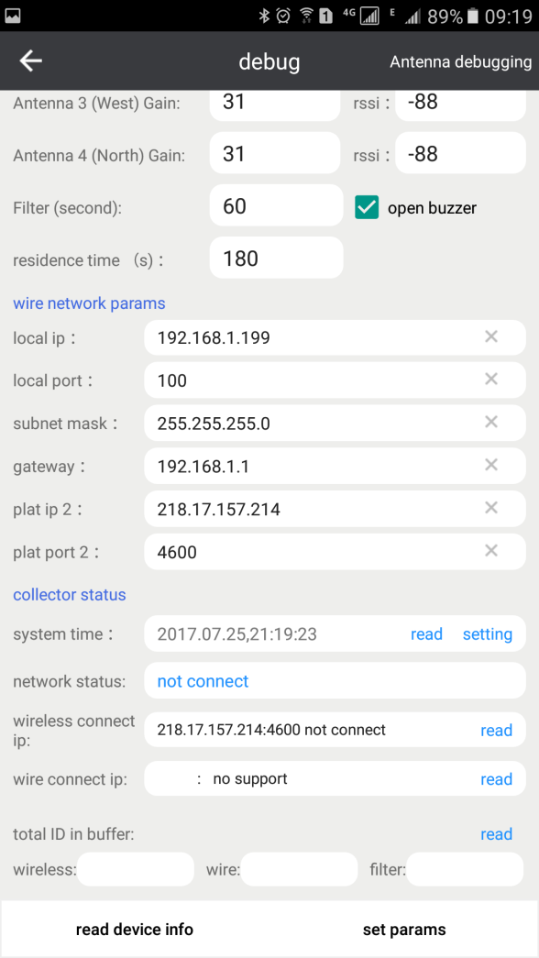

Wire network params

This part used for base station support TCP/IP interface and TCP/IP connecting.(reserved function)

Collector status

System time: real network time

Network status

This part is to check device connect to operator communication network status. Connect success or not connect.

Wireless connect IP

Check wireless network parameter

Wire connect IP

Check wire network parameters

Total ID in buffer

To check how many tags on reader’s buffer.

After set new parameters, should click set params option on the lower right.

Reader will restart automatically to make new parameters available.

### Use Server Demo to check data

A, Use TCP/IP interface to check data.

1, Use LAN cable connect reader to PC directly. (can also connect reader to exchange or router, but WiFi not supported)

2, Make sure the IP address of PC is static IP and set this IP to Reader ( wire network params, plat IP 2.

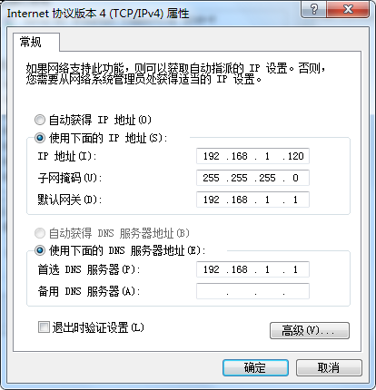

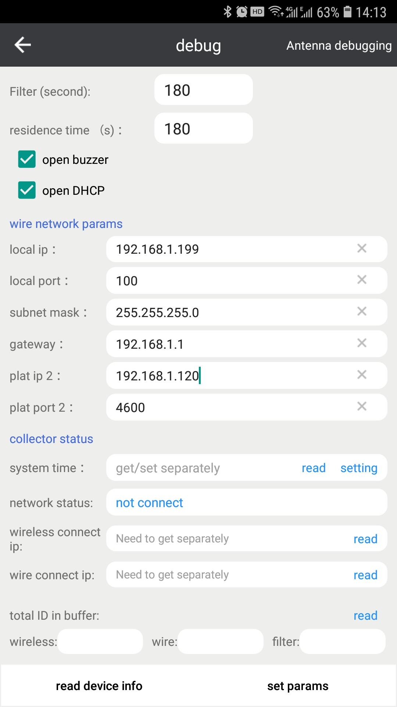

After set params, open the server demo and input the IP and port. Click Start button, reader will output data to server demo automatically.

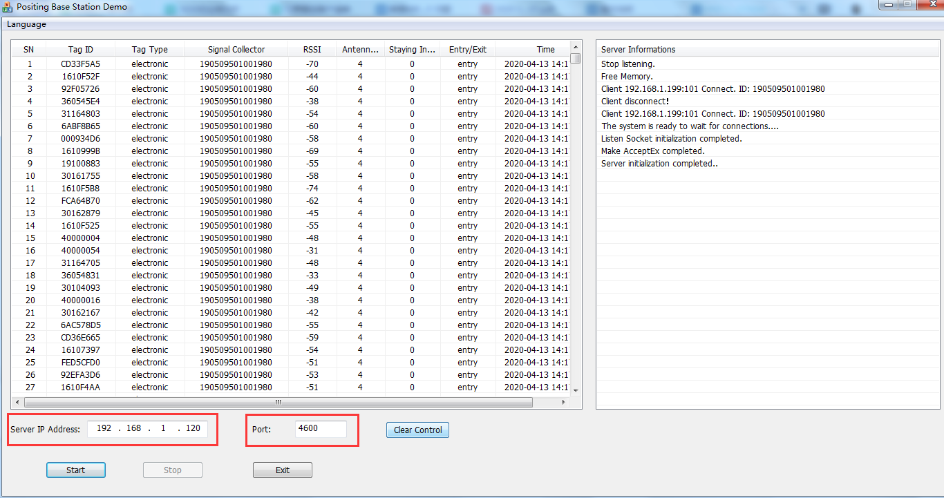

(switch language on upper left corner in cased opened in Chinese

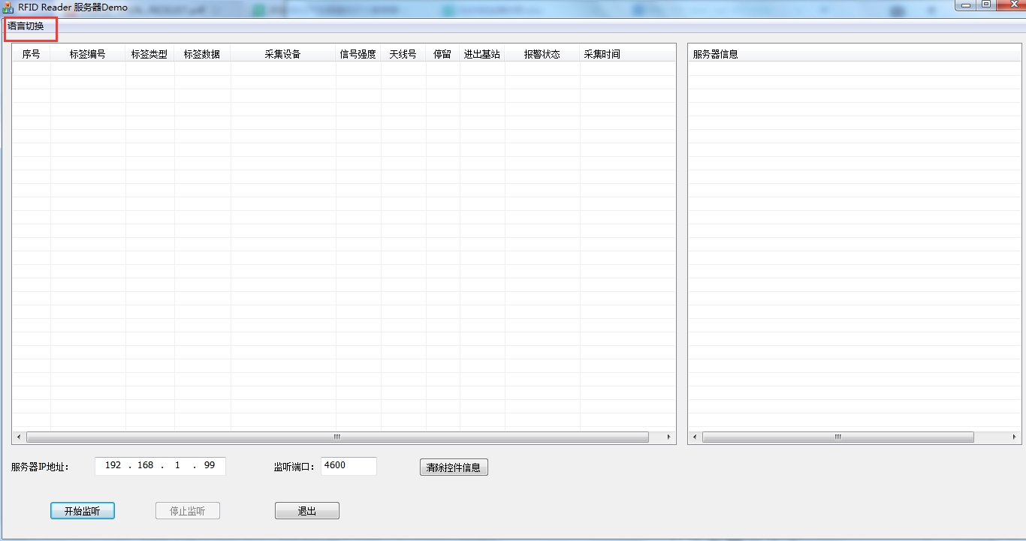)

For PCAttendance Server demo is the same way to do connection.

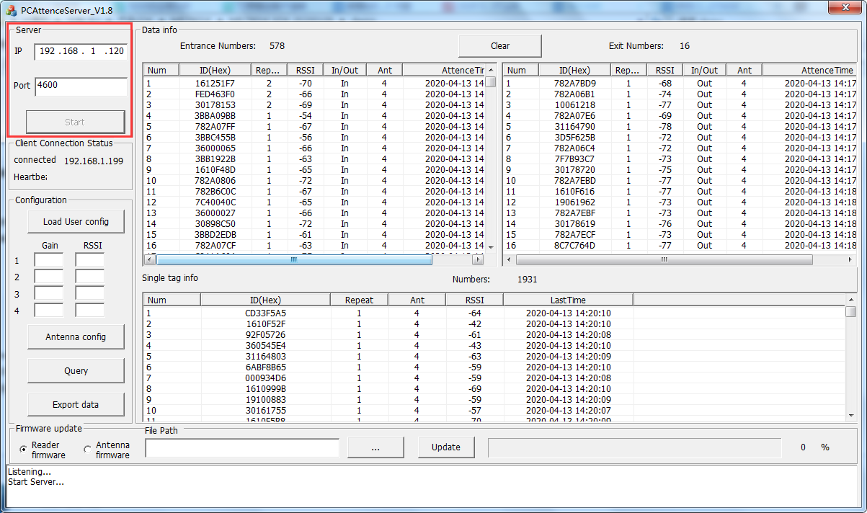

B, Use GPRS (4G) to do connection.

Set Server IP and Port to reader ( wireless network params, plat IP 2)

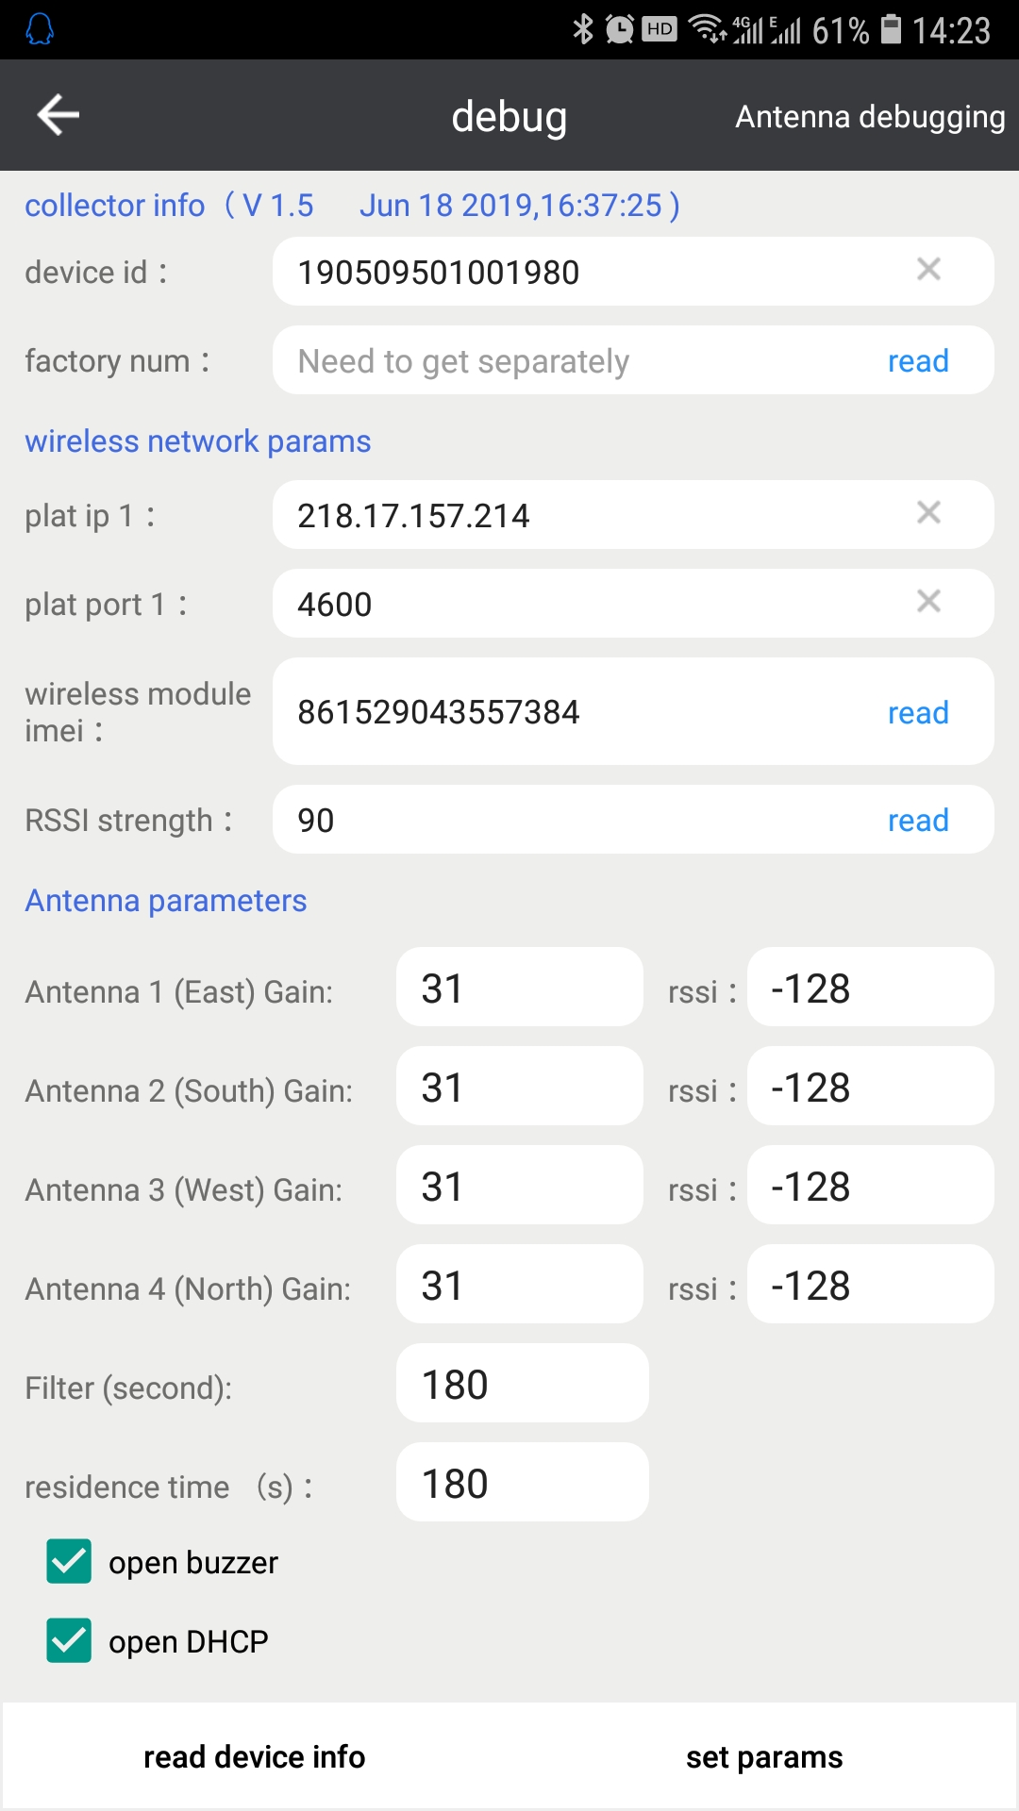

Reader will send data to object Server automatically.

### C, Update reader’s firmware.

After connect reader successful, we can update reader’s firmware if needed.

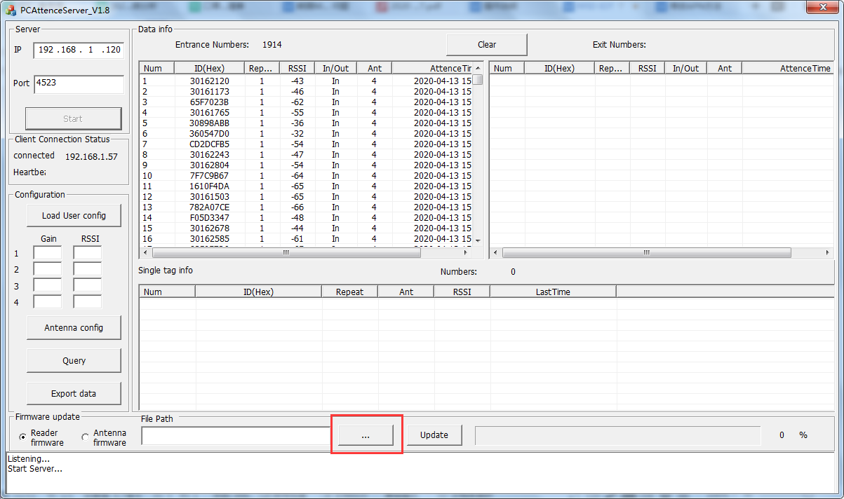

Click the button in red box and choose the Bin file of reader. Then update.

